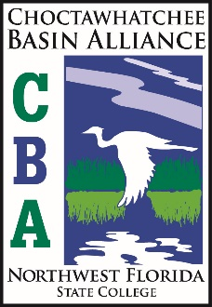
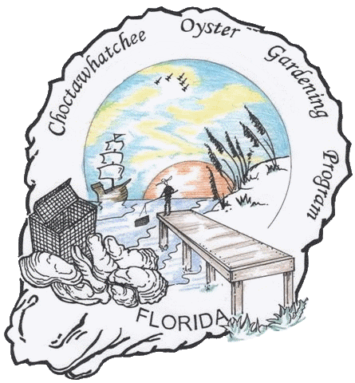
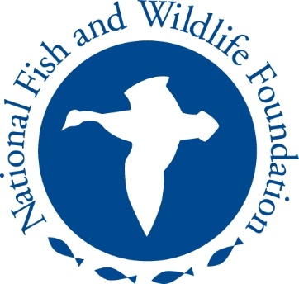
Project of
Choctawhatchee Basin Alliance
Choctawhatchee Oyster Gardening Program
Choctawhatchee Basin Alliance

WARNING
The oysters used in this project are not for human consumption. Their intended purpose is to be used for restoration efforts only.

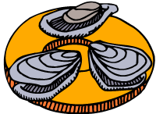
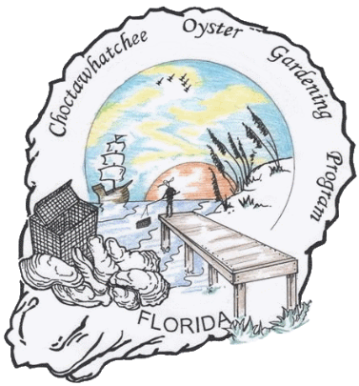
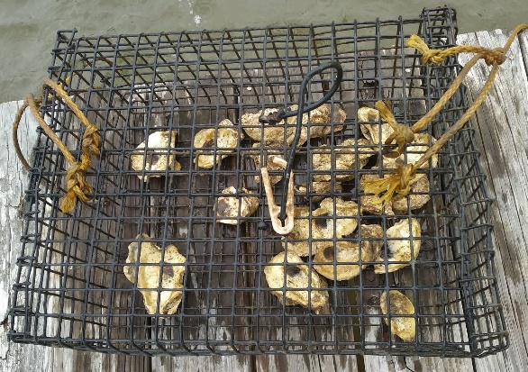
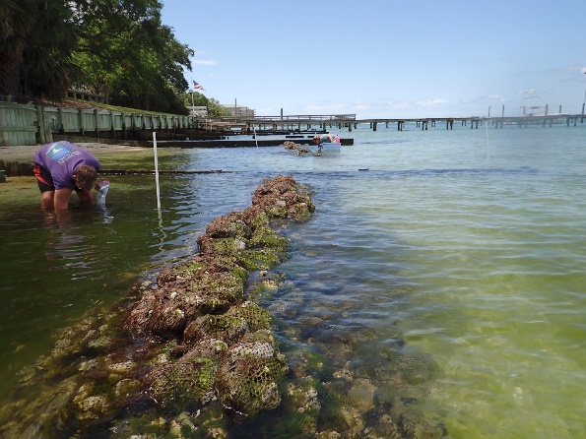
Choctawhatchee Oyster Gardening Calendar

March: Sign Up for Choctawhatchee Oyster Gardening Program
Turn in volunteer form to Alison Jean, Education Technician, at CBA.
April: Attend an Oyster Gardening Workshop
Learn about oyster gardening in Choctawhatchee Bay and how to best care for your oyster garden during the months leading up to our Move Your Mollusk events.
July-April: Weekly Maintenance and Monthly Monitoring
Monitor oyster gardens on a weekly basis for any fouling organisms or predators. Keep oysters free from debris, predators and sediment. Fill out monthly data forms on google forms and upload to CBA oyster database.
April: Move Your Mollusk Event
CBA will collect the oysters and equipment from gardeners for the Move Your Mollusk events in Apri.

Choctawhatchee Basin Alliance was awarded the Five-Star Grant from the National Fish & Wildlife Foundation and Southern Company. CBA is reviving the oyster gardening program for Choctawhatchee Bay residents of Okaloosa and Walton Counties. The original information used in this manual was given to us by the Mobile Bay National Estuary Program (MBNEP) to use in starting our oyster gardening program. Information has been adapted specifically for Choctawhatchee Bay and supplemental information and readings will be available on our website for individuals to read at their own discretion. (basinalliance.org)
Our program will rely heavily on volunteer cage monitoring and CBA has created a simple and easy online form to submit scientific data. These forms will automatically upload to a spreadsheet where CBA staff can access up-to-date data for research and program purposes.

Contents:
Introduction
Why Oysters?
“Oyster Reefs” – Marine Animals Found in or Around Oyster Reefs
Disease & Predators
Principal Diseases & Predators
Fact Sheets
Maintenance & Data Collection
Care & Maintenance
Data Collection
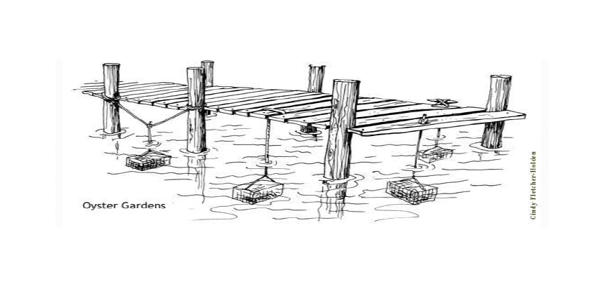
Google Forms
Why Oysters?
The Eastern Oyster, Crassostrea virginica, is a keystone species in an estuarine ecosystem. They are sessile organisms, permanently adhering themselves to a hard surface where they remain for their entire life cycle. This action creates an oyster reef. After generations of oyster larvae landing on the reef, it begins to take shape. An oyster reef will support many different types of animals by providing food, and habitat. Not only are oysters a food source for many foraging animals, they filter many nutrients and particles out of the water column and deposit this pseudofeces into the sediment layer below. This provides fresh substrate and food sources for many benthic organisms and underwater vegetation.
Oysters are natural filter feeders, with individuals filtering up to 50 gallons of water per day. This increases the health of a water body significantly. By filtering out suspended settleable particles and depositing pseudofeces, oysters play an active role in increasing sedimentation rates of an ecosystem. Oysters also filter algae and plankton out of the water column as a main source of food.
According to the Nature Conservatory, 85% of the world’s oyster reefs have been lost due to disease, pollution, declining habitat and over harvesting in the last decade. This makes oyster reefs the most severely impacted marine habitat on Earth (Shellfish Reefs at Risk Report, 2009). The oyster population in Choctawhatchee Bay is no exception. This decline has led to a reduction in biodiversity and water quality. This is because, as NOAA’s Office of Habitat Conservation reports, oysters are a keystone species in the estuarine habitat because of the critical role they have in maintaining the ecosystem.
To address the decline of oyster habitat in the Choctawhatchee Bay watershed, the Choctawhatchee Basin Alliance of Northwest Florida State College (CBA) proposes an oyster reef restoration initiative that will connect on-the-ground habitat restoration with community-based education and training. Through this project, CBA and project partners will restore 1 acre of oyster habitat in Choctawhatchee Bay over two years. Two reefs will be constructed from recycled oyster shell collected through CBA’s established oyster shell recycling program. Harnessing the strength of volunteers, shell will be bagged and placed at the two designated reef locations. Oyster reef habitat is listed as a habitat of concern in Northwest Florida Water Management District’s Surface Water Improvement and Management (SWIM) Plan, which supports this project’s efforts.
In addition to building two oyster reefs in Choctawhatchee Bay, CBA will educate, train and involve community members in oyster restoration through two efforts—1) Choctawhatchee Oyster Gardening program and 2) Spat On! Youth Outreach. By involving the public in these restoration efforts, this project hopes to foster a community of water stewards. NOAA/Nature Conservancy’s Community-based Habitat Restoration program acknowledges that public education is a key component of successful estuarine restoration.
The Choctawhatchee Oyster Gardening program will recruit homeowners to grow oysters in oyster cages at their personal docks. These volunteers will attend a community workshop to introduce oysters’ importance and habitat restoration. The volunteers will also receive an Oyster Gardening Kit to grow their oyster at this training.
All trained community members will move their matured oysters to the two established oyster reefs during a Move Your Mollusk Event—a community action to transplant living oysters to the permitted restoration sites. Currently, the areas around the oyster reef sites are larvae-limited. In other words, although water conditions will support oysters, the two sites lack an abundance of oyster larvae available during spawning. Without larvae, new oysters cannot colonize the reefs. To help the population of oysters develop at these two oyster reefs, the oysters grown by the Choctawhatchee Oyster Gardening program and the Spat On! Youth Outreach will be placed at the two sites.

“OYSTER REEFS”

The oyster reef is a popular place among marine species. Many species seek out reefs for refuge or as a place to hunt for food. Oyster reefs also provide benefits for the bay. Oysters help to cleanse the water of excess nutrients and sediments through their ability to pump water through their gills. The reefs provide structure for other sessile organisms to attach. The crevices provide shelter as well as spawning grounds for other species. Oyster reefs provide a stabilizing structure to keep wave action from scouring the bottom of the bay. Most of these reefs have taken hundreds or thousands of years to form and provide habitat for aquatic plants species, as well.
There are literally hundreds of organisms that will be found in or around an oyster reef. Here is some of the Choctawhatchee Bay “marine crowd:”

Amphipod
There are over 6,000 known species of amphipods. There are many species of amphipods found around the oyster reefs in Choctawhatchee Bay. The most common Suborder is Gammaridea. They are shrimp-like in appearance with hard shell, jointed appendages, and are laterally flattened. They are opaque to translucent in color and usually less than a half-inch in length. Amphipods rely on the reefs for protection, shelter, and food.
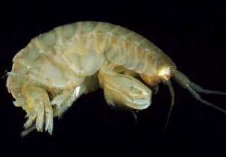
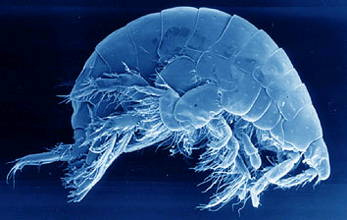

Barnacle
The predominant species of barnacle found in Choctawhatchee Bay is Balanus subalbidus. You will find barnacles attached to the oyster shell. They can be predators of oyster eggs and larvae. Barnacles will grow as large as one inch in diameter.
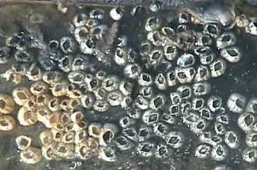

Blue Crab
Blue crabs, Callinectes sapidus, use the crevices in the oyster reef to provide protection and shelter from the species that prey upon them. You can identify these crabs by their bluish-green outer shell and their bright blue claws. The female of this species have red tips on their claws. Barnacles, oysters, and mussels are the “prey of choice” for the blue crab.
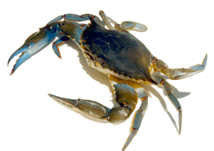
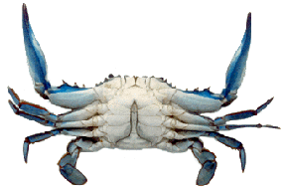
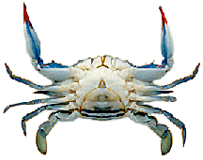
Male blue crab abdomen
Female blue crab abdomen

Hooked Mussel
The predominant mussel species found on oyster reefs in Choctawhatchee Bay is Ischadium recurvum, the hooked mussel. They need the oyster reef to provide a stable structure for them to attach and grow. Their shell color is dark black and may grow up to two inches in length.
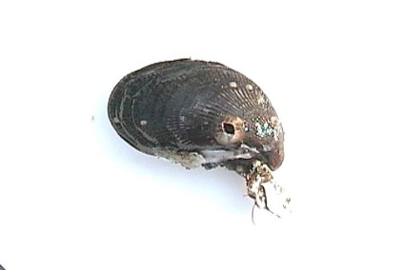

Mud Crab
The mud crab, Panopeus herbstii, is a small species usually less than one-inch in size. Dependent on the oyster reef for protection and shelter, this species of crab eats small oysters, barnacles, and mussels. Their shell is brown and their claws will be either black or pale white in color.
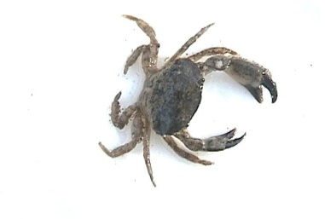

Oyster Flatworm
Oyster flatworms, Stylochus ellipticus, are also known as “oyster leeches.” Oyster flatworms are the least conspicuous predator on the reef. They have flat elliptical bodies with multiple eyes. They are disk-shaped, generally smaller and thinner than a quarter, and usually grayish or flesh colored. Density of the worms varies depending on the location and the season, but they are more prevalent in the summer. The flatworm needs the oyster reef to provide shelter and protection from its predators. Flatworms will eat small oyster spat.
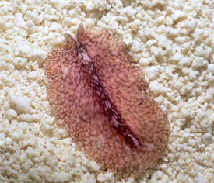

Polychaete Worm
There is no single species of worm that dominates the oyster reefs in Choctawhatchee Bay; many species live here. Some worms may live in the crevices of the oyster reef and some may build mud or calcium at the inside edge of the oyster shell. They can grow to be 6 inches long and are reddish in color.

Sea Anemone
There are over 1000 species of anemones found in coastal waters worldwide. Sea Anemones are usually about 1 to 4 inches (2.5-10 cm) across. They are many shapes, sizes, and colors. Radially symmetric, they have a columnar body with a single body opening, the mouth, which is surrounded by tentacles. The tentacles have microscopic stinging capsules, which are used to protect the anemone and catch its food. Sea Anemones are carnivores that eat fish, mussels, zooplankton (copepods and small crustaceans) and worms. They have very few predators.
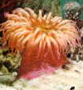

Sea Squirt
Sea squirts, Molgula manhattensis, may grow to two inches in diameter. They may be gray-green or brown in color. They are tunicate-animals named for their flexible, tough outer covering or "tunic". The will squirt water when removed from the water. They have been observed most prevalently in the winter in Mobile Bay.
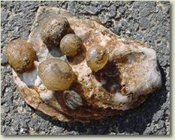
Sea Squirts
Photo courtesy Chesapeake
Bay Foundation

Southern Oyster Drill
The southern oyster drill, Stramonita haemastoma, is a gastropod and primary oyster predator in the Gulf of Mexico. Oyster drills are slow moving snails that may reach 2 inches in length. They have a heavy, brown shell and are bottom dwellers (unable to swim). They will drill a pin size hole in the oyster shell and suck the oyster out.

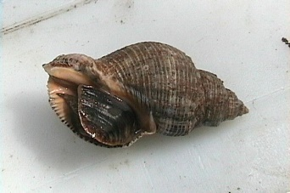
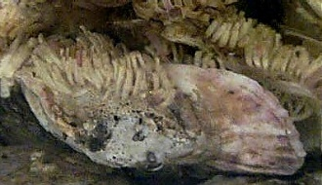
Oyster Drill eggs

Stone Crab
Stone crabs are found in many areas along the Gulf coast. The species found in Choctawhatchee Bay is Menippe adina. The small, very young crabs are dark purple in color. Adult stone crabs are deep chocolate brown in color. They use the oyster reef for protection and shelter as well as a place to find food.
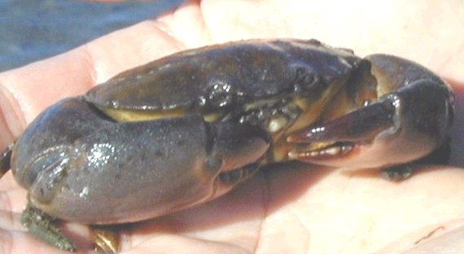

Atlantic Croaker

The Atlantic Croaker, Micropogon undulates, belongs to fish in the drum family and is found from Massachusetts to Florida and throughout the Gulf of Mexico. Croakers get their name from the sound they make when captured. They make this sound by tightening the muscles that surround their swim bladders to communicate between fish and to locate a mate. They have a silver-gray or bronze body with dark oblique wavy bars or lines; iridescent especially on head; preopercle strongly serrated and usually weigh less than 2 pounds. Feed on worms, crustaceans, and small fishes.
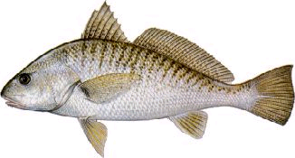
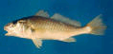

Black Drum
The Black Drum, Pogonias cromis, is a large fish that is commonly 30 pounds. They are a commercial and sport fish. They feed on oysters, mussels, crabs, shrimp and occasionally fish.

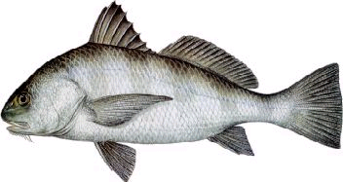
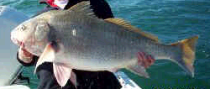
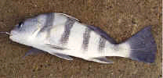
Adult
Juvenile

Mangrove Snapper

The mangrove (gray) snapper, Lutjanus griseus, is dark brown or gray with reddish or orange spots in rows along the sides with a dark horizontal band from snout through eye (young only). They feed on crustaceans and small fish and commonly reach up to 10 lbs.
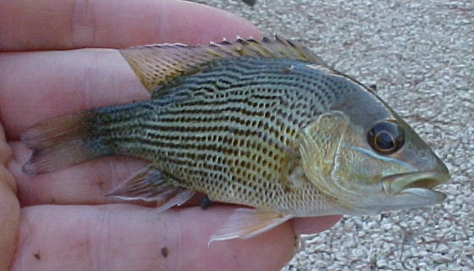
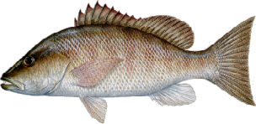

Naked Goby
The naked goby, Gobiosoma bosci, looks to the oyster reef to provide protection from its predators and for species it preys upon. You will find this fish swimming in and around the oyster reef. Often, they will make their homes in dead oysters, called “oyster boxes”. They prey on polychaete worms and small crustaceans. There are no scales on their bodies, hence their name. A naked goby can grow up to 2.5 inches long. Their greenish-gray back, pale belly, and narrow pale crossbars on their sides identify this species.
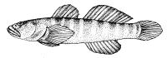
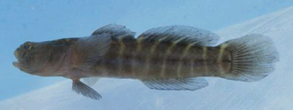

Oyster Toadfish
While this species, Opsanus tau, will eat oysters, they prefer crabs and may actually protect the oyster reef from crab predation. Their bodies have no scales and are vertically compressed. They possess a large mouth, sharp teeth, bulging eyes, fleshy whiskers, and a broad, flat head. Growth up to 1½ feet is possible. Their skin is pale or yellowish brown with brown blotches. Toadfish use the oyster reef for protection from their predators.
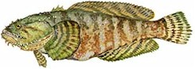
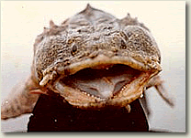

Pinfish

Pinfish, Lagodon rhomboids, are popular live bait that lives in seagrass beds and around bridges, piers, marker pilings, and natural and artificial reefs. They have a distinctive black spot behind the gill cover with a bluish-silver body with blue and orange-yellow horizontal stripes and yellow fins. They will eat polychaete worms and small crabs and seagrasses as they get older.
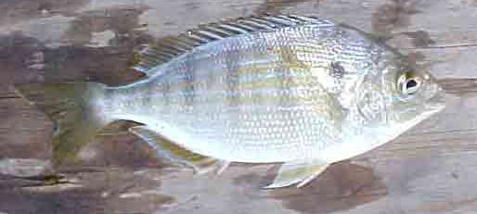
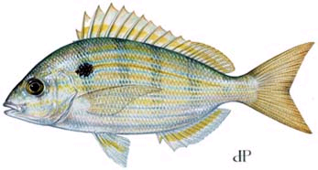

Red Drum

Also referred to as Redfish, Red Drum, Sciaenops ocellata, have a copper bronze body with large scales and one to many spots at base of tail. Their mouth is horizontal and opens downward. They are generally bottom feeders on worms, crabs, shrimp and small fish.

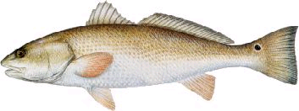

Sheepshead
The sheepshead, Archosargus probatocephalus, is a large fish that can exceed two feet in length and weigh as much as 21 pounds. They are a commercial and sport fish. Their feeding habits bring them around the oyster reefs. Sheepshead feed on barnacles and various species of crabs that are also found on the reefs.
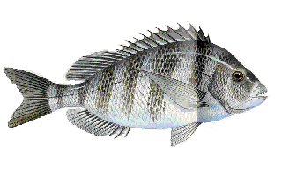
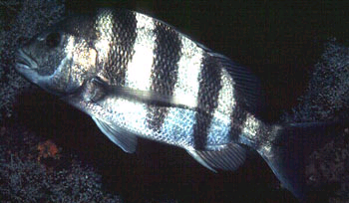

Skilletfish

This species, Gobiesox strumosus, has a scale-less body with a large sucking disk on its belly. They make their home in oyster boxes (empty oyster shells) and will often lay their eggs in them. Skilletfish are medium to light gray with brown speckles and can grow up to 3 inches. They are often found clinging to the outside of an oyster shell. Using the oyster reef as protection from predators, they also find an abundance of food from small crustaceans to polychaete worms.

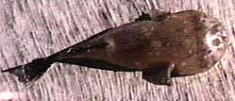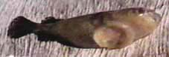

Southern kingfish
Southern kingfish, Menticirrhus americanus, also known as whiting, are popular food and game fish that range from silver-gray to copper colored with darker markings on the sides. The species is a medium-sized member of the croaker family with a slender body, a small inferior mouth, and a single, rigid chin barbell. They eat worms, shrimp, shrimp larvae, crabs, amphipods, and small fish.

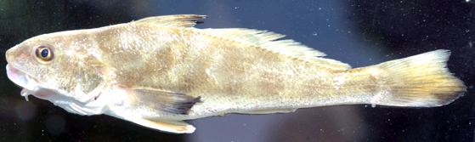
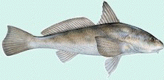

Spotted Sea Trout
Spotted sea trout, Cynoscion nebulosus, also known as speckled trout, are frequently found among oyster reefs during the spring and summer. They generally range from one to three pounds but can be larger. The spotted sea trout is an important sport fish in coastal Alabama. I’ve certainly got better pictures of speckle trout!
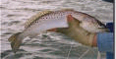
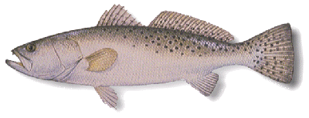

Striped Blenny
The striped blenny, Chasmodes bosquianus, finds an oyster reef the protective environment. They have a long dorsal fin and a laterally compressed body. Males are olive-green with blue horizontal lines that converge at the tail. Females are a darker green with pale green stripes. This species can grow up to three inches in length. Their food preferences are small crustaceans and mollusks
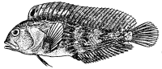
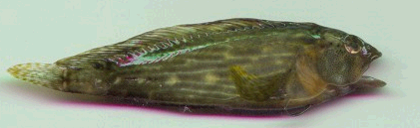

White Trout
White trout, Cynoscion arenarius, also called sand seatrout, have a pale body color (yellow above, silver to white below) and one or two prominent canine teeth usually at the tip of upper jaw and inside of their mouth is yellow. They are usually less than one pound and feed on shrimp and small fish.
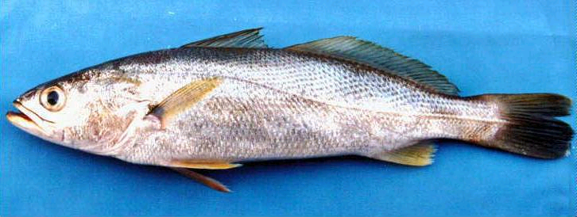
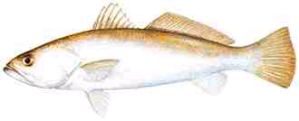

Introduction to Oyster Diseases

A disease as defined by the American Heritage College Dictionary is:

A pathological condition in an organism resulting from infection or genetic defect, for example, and characterized by identifiable symptoms.

Disease is a broad term designating damage to cells sufficient to cause dysfunction of the organism. Infection refers to the presence of an infectious or foreign organism in tissues of the host, in this case the oyster.

Stress is a state produced by any environmental or other factor which pushes the adaptive responses of an animal beyond the normal range or which disturbs the normal functioning to such an extent that chances of survival are significantly reduced.

When describing diseases in human medicine the term “symptom” is used. This refers to characteristics of a particular disease condition. In animal medicine, we refer to “clinical signs” of disease, since these must be detected by examination rather than a verbal description from the patient.

Diseases may be caused by:

Non-infectious agents – not transmissible
- Genetic defects resulting in abnormal cellular structure and function
- Nutritional imbalances that deprive cells of essential nutrients
- External physical or chemical agents that injure cells

Infectious agents – transmissible agents that damage cells by their actions or presence

- Parasites – e.g. Perkinsus marinus (Dermo) and MSX
- Bacteria – e.g. Vibrio and Pseudomonas species
- Fungi – e.g. Ostracoblabe implexa (shell disease – wart-like at adductor muscle)
- Viruses – e.g. Herpes-like virus around blood sinuses

Method of disease control:

- Remove dead oysters
- Keep floats clean
- Water quality (e.g., dissolved oxygen >5ppm)

Principal Diseases & Predators
Eastern Oyster (Crassostrea virginica)

Disease | Description
Dermo, Perkinsus marinus  (protozoan) | Prevalent in the Gulf of Mexico and on the East Coast of the US from Florida to Massachusetts. Causes high mortality at temperatures above 20⁰C and salinities greater than 12-15 ppt. Transmitted directly from oyster to oyster.
MSX, Haplosporidium nelsoni  (protozoan) | This disease is not yet found in Gulf waters. Prevalent along the Atlantic coast of the US. Active at temperatures above 10⁰C and cannot survive in salinities below 10 ppt. Causes oyster mortality in summer and fall. Transmission methods unknown.
Predator | Description
Black Drum Fish, Pogonias cromis | Have large teeth used to crush the oyster shell.
Blue Crab, Callinectes sapidus | Primary oyster predator along the Gulf of Mexico. Identified by its blue colored claws.
Mud Crab, Panopeus herbstii | Small crab. Brownish color shell with pale white or black claw tips.
Oyster Flatworm, Stylochus ellipticus | Small, flat worms. Primarily a threat to very young oysters.
Oyster Drills, Stramonita haemastoma | Slow moving snail with a heavy shell. Primarily a threat to very young oysters.
Rays, Dasyatidae | Flat fish with an average size of 50 cm.
Stone Crab, Menippe adina | Large claws of unequal size. Shell can be gray, tan or deep chocolate brown.

The following pages are the above listed disease and predator fact sheets.
Dermo Disease Fact Sheet
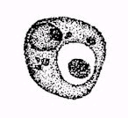
Scientific Name: Perkinsus marinus
Dermo cell
Common Name: Dermo, Perkinsus

Geographic Distribution: East coast of the U.S. from Maine to Florida and along the Gulf of Mexico Coast to Venezuela. Dermo is also documented in Puerto Rico, Cuba, and Brazil.

Dermo was discovered by Mackin et al in 1950 and occurs approximately every three to four years in Choctawhatchee Bay. It is a protozoan parasite but was originally thought to be a fungus. Much of the Dermo research was conducted in the 1970’s. Recent DNA studies suggest that dermo is related to the dinoflagellates.

Transmission of this disease is directly from oyster to oyster. It is important to avoid moving infected oysters to an area where there are uninfected oysters. Waterborne infective stages of the parasite are present throughout the warm months, May through October. Within the oyster, the early infections are seen in the digestive gland tissue. Usually, dermo is not found in oysters less than one year old. Occurrences of this disease during the second year increase significantly thus increasing the mortality rate.

Temperature and salinity are the two most important environmental factors influencing dermo. The parasite thrives in warm water with temperatures above 20⁰C and oyster mortality increase in water warmer than 25⁰C. Abnormally warm winters often result in higher occurrences of the disease during the following summer. Drought conditions bring destructive outbreaks of dermo due to higher salinity levels. Salinity levels of 0-9 ppt allow the parasite to survive but cause light infection rates. Levels of 9-15 ppt allow the parasite to develop slowly and cause low mortality rate in infected oysters. In salinity levels of 15 ppt or higher the parasite multiplies rapidly and mortality rate is highest.

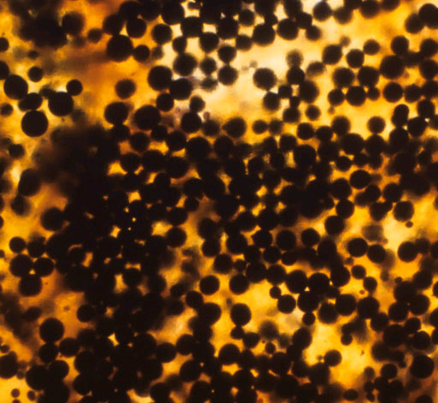
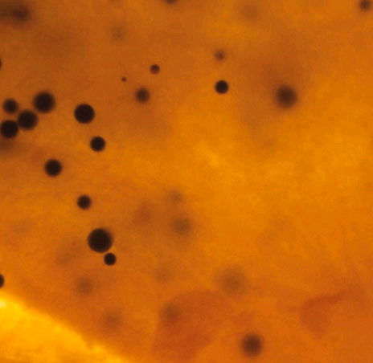
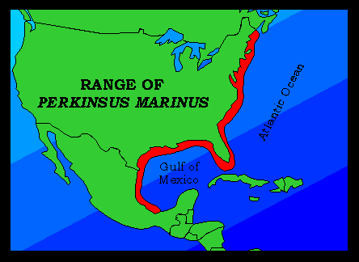

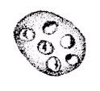
MSX Disease Fact Sheet
MSX plasmodia
Scientific Name: Haplosporidium nelsoni
Common Name: MSX (multinucleated sphere unknown)

Geographic Distribution: In the United States, MSX disease ranges from Damariscotta River, Maine to Biscayne, Florida. It is not present in the Gulf of Mexico (and it is not present in Choctawhatchee Bay). Outbreaks affecting a large number of oysters have been limited to the Chesapeake and Delaware Bays and recently Long Island Sound. The parasite has also been found in oysters in Korea and Japan.

This disease was first documented in Delaware Bay in 1957 causing massive oyster die-offs. In 1959, MSX was found in lower Chesapeake Bay. By the 1960’s, the disease was found in numerous coastal bays along the east coast affecting North Carolina, Virginia, Maryland, Delaware, New Jersey, Connecticut, and New York, although die-offs were not occurring south of Virginia or north of New Jersey. During the 1980’s, MSX was documented all along the east coast from Maine to Florida.

Haplosporidium nelsoni is a spore-forming protozoan. Transmission paths of this disease are unknown but it is believed to occur through the release of spores. This disease affects oysters of all ages and the infections are acquired through gill and mantle tissue. Mortality of oysters occurs from early spring through autumn. The most susceptible period of oyster mortality will occur from July through October.

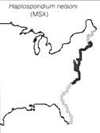
Temperature and salinity are the two most important environmental factor influencing MSX. The water temperature must be above 20⁰C for an oyster to acquire this disease. There are three critical temperatures for MSX. At temperatures less than 5⁰C the MSX parasite and oysters are inactive. From temperatures of 5⁰C to 20⁰C the parasite multiplies faster than the oyster can control it. Above 20⁰C, resistant oysters can overcome the parasite while susceptible oysters are killed. Salinity within an estuary is an important factor in the occurrence of MSX. Salinities over 15 ppt are necessary for this parasite to survive. A level of 20 ppt is necessary for rapid and high mortality. At a temperature of 20⁰C and salinity levels of 10 ppt or less the parasite cannot survive.
MSX is not present in Mobile Bay at this time. One factor may be a lower salinity level than is necessary for the MSX parasite to exist. The Department of Conservation and Natural Resources – Marine Resource Division is very careful not to allow non-native oysters to be imported or planted in Mobile Bay.

Black Drum Fact Sheet

Scientific Name: Pogonias cromis
Common Name: Black Drum
Geographic Distribution: The black drum is found along the Atlantic Coast from New York south through the Gulf States to Mexico.

Black drum is an important commercial and sport fish in the Choctawhatchee Bay area. This species tend to be found in large schools. They have very heavy teeth used to crush the oyster’s shell. Black drum feed especially on the small "seed" oysters. These fish are most commonly found in the southern portion of the bay, especially near Cedar Point Reef, but are also found in the Mobile Delta. Black drum can tolerate varying salinities.
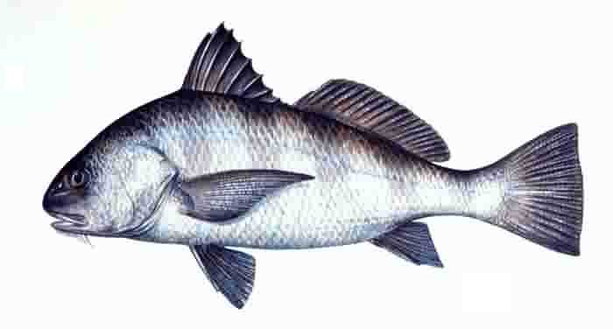

Juvenile
Adult

Blue Crab Fact Sheet

Scientific Name: Callinectes sapidus
Common Name: Blue Crab

Geographic Distribution: This crab is found as far south as Venezuela and as far north as Massachusetts.

Crabs are scavengers and prey on oysters and clams. Blue crabs rely on oyster reefs for protection from their predators and the reefs provide the perfect feeding ground for them. They use their strong claws to crush the shell of their prey, chipping the edge of the shell, or forcing the valve apart. The blue crab consumes any size oyster from seed size (6 to 12 mm) to market size (>75mm). The rate of predation can be very high on unprotected oyster beds. In culture situations, placing the oysters in cages with lids for protection can limit blue crab predation.

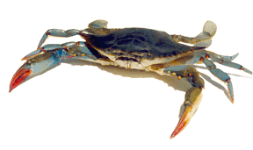
Mud Crab Fact Sheet
Females – View abdomen and note red claws
Males – View abdomen and note blue claws

Scientific Name: Panopeus herbstii
Common Name: Mud Crab

Geographic Distribution: This species is found from Boston Harbor south to Brazil.

Mud crabs are very small (less than one inch). They are inhabitants of oyster reefs and, like the blue crab, enjoy making a meal of oysters. They use their large, tooth-like claw to chip away at the shell of the oyster. Mud crabs select small oysters 12 to 19 mm in height. Its brownish colored shell and the claw tips, which are either pale white or black, can identify this species.

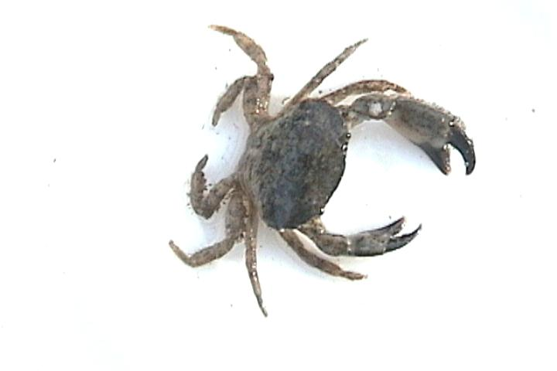
Oyster Flatworm Fact Sheet

Scientific Name: Stylochus ellipticus
Common Name: Oyster Flatworm

Geographic Distribution: Found in the Mid-Atlantic region and throughout the Gulf of Mexico

Oyster flatworms are not true predators of the oysters, but they can damage or destroy the oyster. The flatworm will cause blisters to form on the muscle the oyster uses to close its shell. When this happens the shell will not completely close, allowing the worms to enter the shell and eat the oyster meat. Flatworms are thin, flat, and elliptical in shape. They are usually one inch or less in size but can grow bigger. Their color will vary.
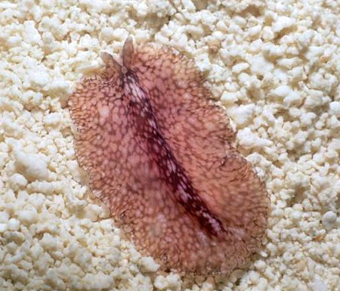
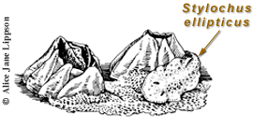
Oyster Drill Fact Sheet

Scientific Name: Stramonita haemastoma
Common Name: Southern Oyster Drill

Geographic Distribution: Found along the Atlantic and Pacific coasts as well as the Gulf of Mexico.

The oyster drill, a gastropod, is the primary oyster predator in the Gulf of Mexico. It is also a significant threat in Choctawhatchee Bay. Oyster drills are small, slow moving snails with a heavy shell. They will drill a pin size hole in the oyster shell and suck the oyster out. Their preferred method of attacking an oyster is to bore between valves at the bill, their weakest point. It can take up to three weeks to eat one large oyster. These predators will attack any oyster but they are most devastating to very young oysters.

The greatest density of oyster drills will be found where the water is the most saline, usually near the mouth of the bay. The range of oyster drills is limited by salinity. Salinity greater than 15 ppt is needed for its survival. During the late 1960’s, the oyster drill in Mobile Bay killed 80% of the oyster spat in a nine month period where salinities were over 15 ppt. At a salinity of 7ppt this predator will become immobile and if it remains at that level for one to two weeks the oyster drill will die. Flooding conditions that bring a great amount of freshwater will eliminate the oyster drill.

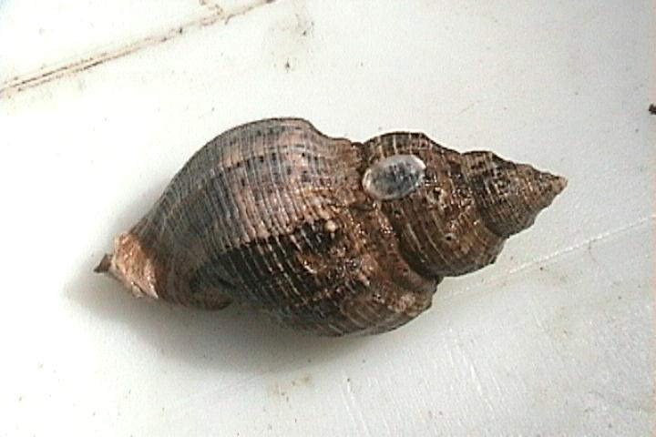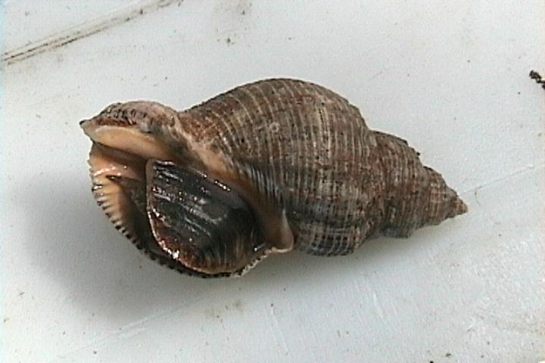

Dorsal View Ventral View

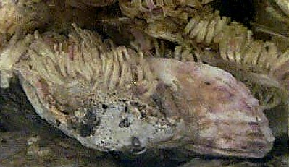

Oyster Drill Eggs
Atlantic Stingray Fact Sheet

Scientific Name: Dasyatis sabina
Common Name: Atlantic stingray

Geographic Distribution: Rays are found all over the world including estuaries.

Atlantic stingray, the predominate species on Gulf coast reefs, is a flattened fish that is closely related to the sharks. Rays vary in size but you will probably find only smaller rays in Choctawhatchee Bay. The average size of rays is around 50 cm. These fish will hunt for food on the bottom of the bay. While they eat fish, crustaceans, and worms, rays also eat oysters. The ray will use its rostral lobes to dislodge the oyster from the reef then crush it with their flat, plate-like teeth.

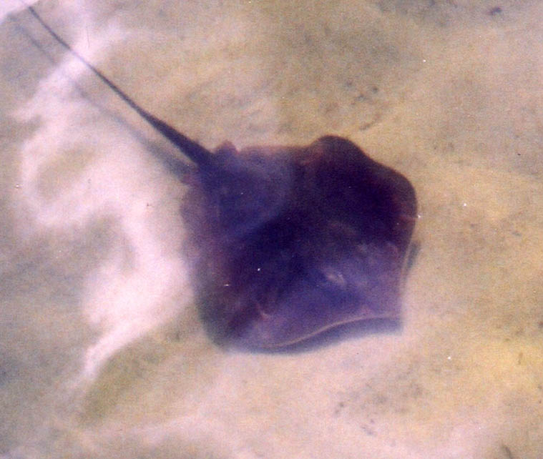
Stone Crab Fact Sheet

Scientific Name: Menippe adina
Common Name: Gulf Stone Crab

Geographic Distribution: Found along the northern and western gulf coast region.

Stone crabs use the oyster reef as habitat and source of food. The young crabs are greenish or bluish gray to gray or dark tan in color with dark spots on its shell. The adult crabs are deep chocolate brown color. Their pincher claw is used to hold an oyster while the larger claw is used to crush the shell.

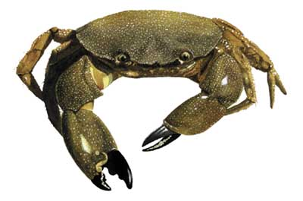

Care and Maintenance

There are three things that will be the most important maintenance tasks for oyster gardening: (1) keep the float clear of fouling organisms such as barnacles, mussels, and algae; (2) remove sediment and oyster feces that will collect in the float; and (3) remove predators that will invade your float and feed on the young oysters. Your float will need to be pulled from the water and allowed to dry out.

Control of Fouling Organisms
Drying out or desiccation can control most barnacles and mussels. This will be accomplished by lifting the growout cage out of the water and letting it sit on the dock, exposed to the fresh air. The young oysters can survive extended periods exposed to air. Letting your oysters sit in hot, direct sunlight for more than a couple of hours is not recommended. Keeping the float shaded will help to reduce the fouling while increasing the chance of oyster survival. On cloudy or rainy days, the oysters can survive for a longer period of exposure to the air. Your floats should be left out in the air as often as every two weeks during the winter and as often as once a week during the summer. Each site will vary in the method and length of time needed to control the fouling organisms.

Filamentous algae are persistent fouling organisms. The algae do not harm the oysters but it does make it hard to observe the growth of the spat. The best way to control the algae is to make sure it does not have a chance to grow. When you observe algae beginning to grow on your float you should begin the routine of letting your float air out in the sun. Once the alga becomes established it will grow very quickly. If the float is heavily fouled with algae, remove as much as possible before the desiccation process. It is possible to control the algae growth by limiting the amount of sunlight reaching the float.

If you cannot control the growth of barnacles, mussels, or algae using the drying out method alone, you will need to take a more direct approach. Scrubbing the float with a hard bristle brush will help remove the algae. Scraping with a hoe can remove barnacles. A high pressure hose is one of most effective tools to remove fouling organisms.

Cleaning Growout Cages
The cages will trap sediment that is suspended in the water. The problem you have with sediment will depend on where you are located. Some areas may have a high load of suspended sediments, while others may not. Examining the bottom sediments near your pier will be an indication of the problem you may have. Sandy sediments are seldom a major problem because the larger grains will tend to settle out of the water because of their size. Floats located in areas where high wave activity occurs may have to clean their float after a major storm.

If your area has fine clay sediment, this will be more of a problem. The oysters in the float will catch the sediment as it falls out of the water. Oysters will also remove some of the sediment and algae through their own water filtering process. The waste product of the oyster, known as “pseudofeces” will contain some of the sediment as well as the natural oyster waste. Waste particles will be dropped and accumulate on the bottom of the float. Both the sediment and the oyster feces can be a problem with the survival of your oysters. Without routine cleaning, the oysters can quickly become covered which will inhibit their ability to feed and breathe. The oysters that are trapped below the sediment will probably die. For this reason, your cages must be cleaned on a regular basis. The time between cleaning will vary depending on the location of your float and the season. All floats will need to be cleaned as often as every two weeks. Cleaning can consist of moving the float up and down in the water until all the sediment is rinsed off, or by using a hose if one is available. When cleaning your float do not remove the dead oysters from the float because they will need to be counted when collecting data on your oysters.

Source: Oyster Gardening for Restoration & Education.
William Goldsborough, Donald Meritt

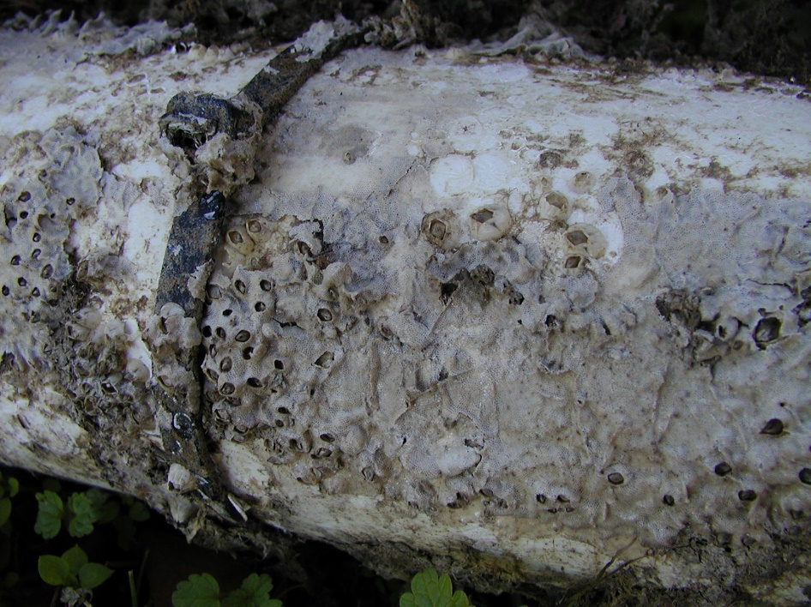
Dried Barnacles

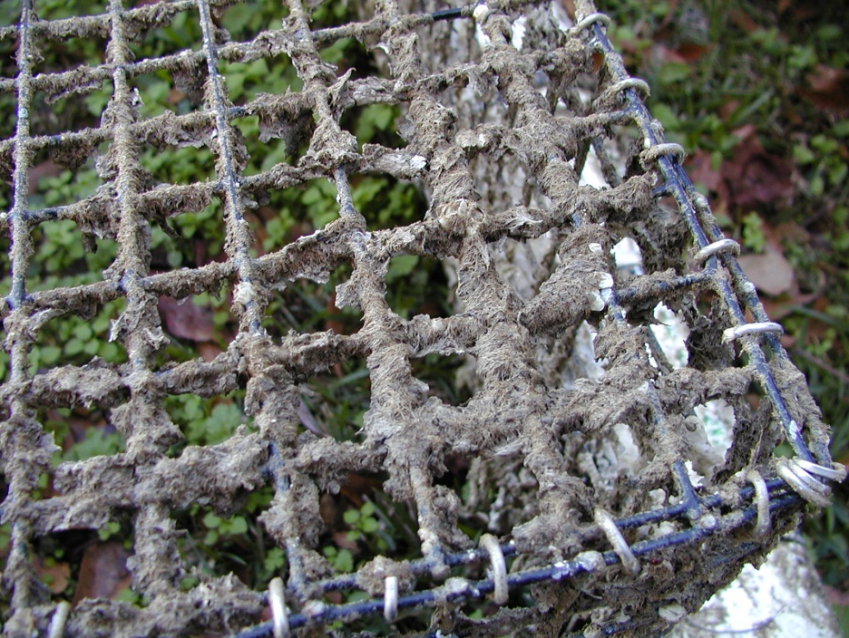
Dried Algae
Data Collection

When collecting data from your oyster garden, be sure that the oysters and cage is cleaned for accurate readings.
- Measure the largest oyster spat and measure from anterior to posterior with the pocket calipers in your oyster gardening kit. Be sure to record data in millimeters.

- Measure the smallest oyster spat and measure from anterior to posterior with the pocket caliper in your oyster gardening kit. Be sure to record data in millimeters.

- Record the presence of organisms, friend or foe, by checking all the boxes that apply to your oyster garden.

Barnacles | Amphipods
Algae | Shrimp
Bryozoans (moss animals) | Mussels
Crabs | Gastropods (snails)
Isopods | Annelids (worms)

Tips: Bring a notepad to the oyster garden and collect data at the dock.

Google Form Submission
Visit the Choctawhatchee Oyster Gardening Program page, under the education menu, on CBA’s website, www.basinalliance.org. Scroll down to the data collection section and submit the appropriate forms.
- Monitoring Data - This should bring you to the google form where your information along with cage data will be submitted. Both Gardeners and Allies will fill this out for monitoring purposes.

- Volunteer Hours Log –This form should be completed whenever an Oyster Ally is in the field with a CBA staff member or monitoring cages on a public dock. Both Gardeners and Allies will use this form to submit volunteer hours for attending reef bag/build events and Move Your Mollusk events.

